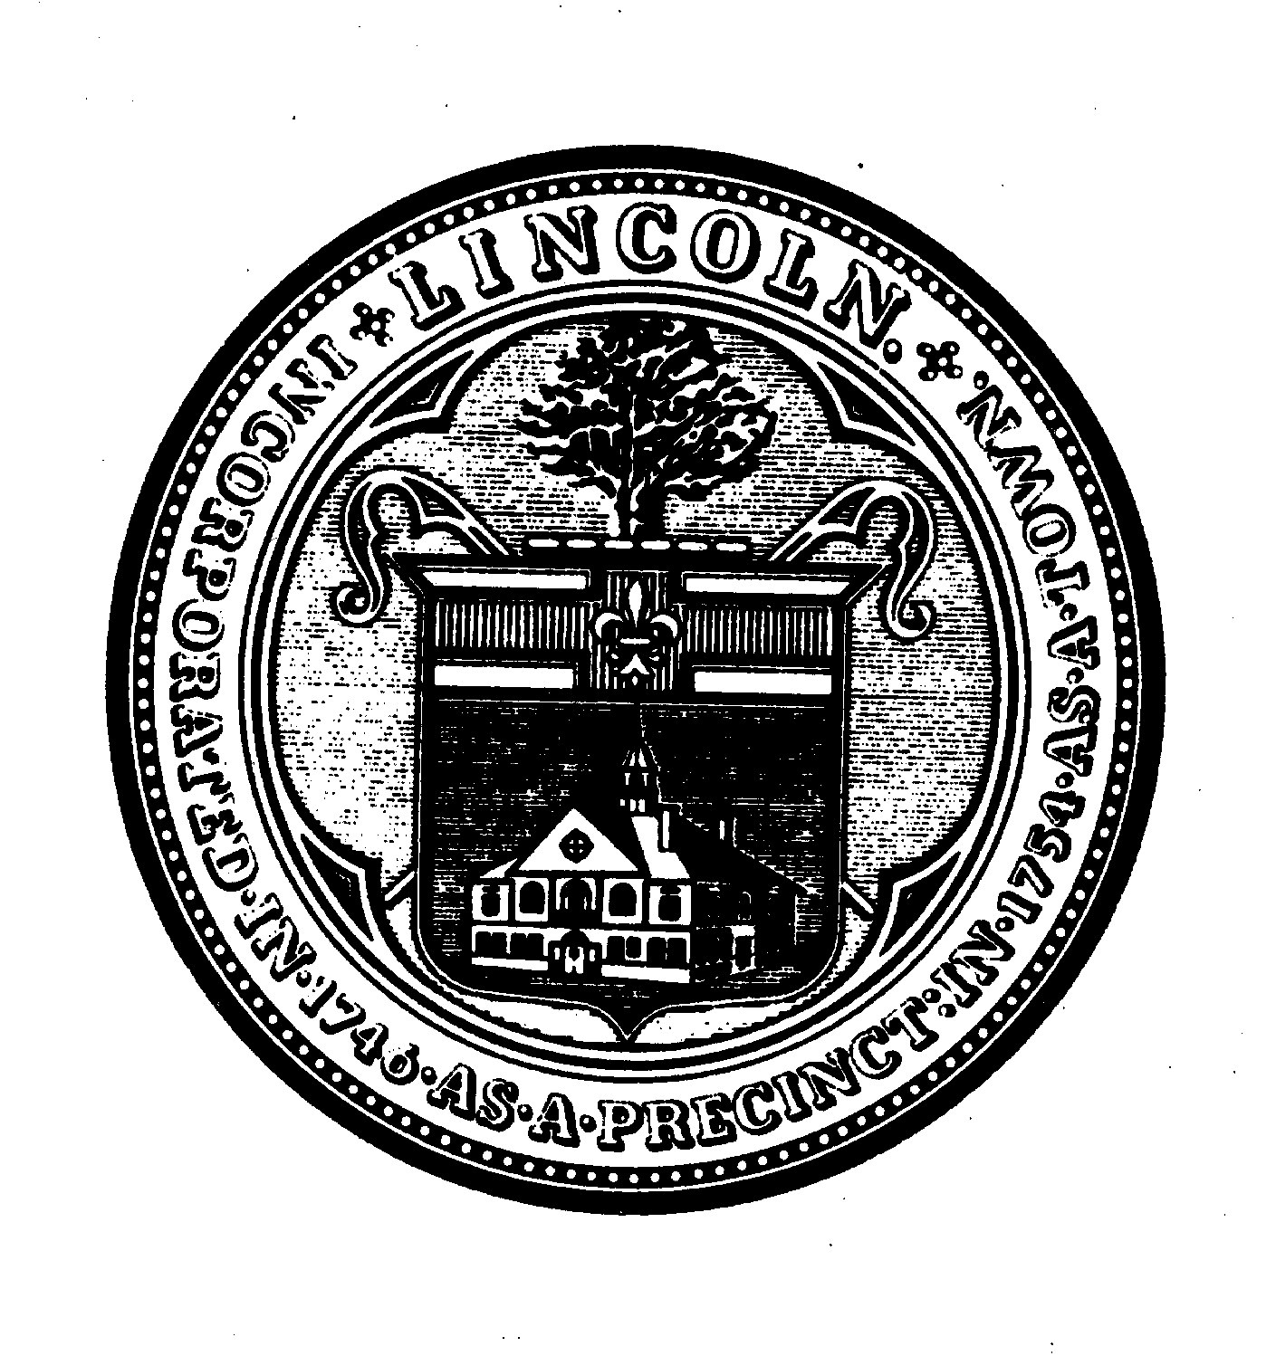
TOWN OF LINCOLN Ammended

LINCOLN TOWN OFFICES
16 LINCOLN ROAD
LINCOLN, MA 01773
781/259-2601

Jim Hutchinson, Chair
Kim Bodnar
Jennifer Glass
Select Board

Select Board Meeting
Monday, October 16, 2023 – 6:30 p.m.
Hybrid Meeting Format
This meeting of the Select Board will be conducted as a hybrid meeting, providing
the public the option of participating in-person or remotely.
Meeting Agenda
- Welcome & Introductions
- Announcements
- Appointments
6:30 p.m. Andrew Stephens, Superintendent
Lincoln-Sudbury Regional High School
Re: Welcome & Introductions
6:45 p.m. Chief Kennedy
Re: Sergeant Appointment
7:00 p.m. Pierce House Committee
Re: Budget Update
7:30 p.m. Planning Board
Re: Housing Choice Act Update

- Public Participation
    - The Chair will invite questions and comments after the Board has discussed the above items.

- Town Administrator’s Report
- Discussion
- State of the Town Meeting - Reflections
- Housing Choice Update
- Community Center Planning Update
- Inclusion Diversity Equity & Anti-racism (IDEA) Update
- Linc 250th Planning Update
- Liaison Reports

- Action Items
- Review Board’s Meeting Schedule
- Review Prior Action Items
- Review Correspondence
- Approve Warrants & Minutes

- Executive Session
Open meeting with the possibility of entering into executive session in accordance with MGL, c. 30A, s. 21 (a), exemption #6, for the purpose of considering the purchase, exchange, lease or value or real property in the chair declares that an open meeting may have a detrimental effect on the negotiating position of the Town.

Remote Participation Protocols ________________________________________________________________________________________________
Pursuant to Governor Baker’s March 12, 2020 Order Suspending Certain Provisions of the Open Meeting Law, G.L. c. 30A, §18, as further extended most recently by Governor Healey’s March 29, 2023 signing of a bill extending said authorization to March 31, 2025, this meeting of the Lincoln Select Board will be conducted as a hybrid meeting, providing the public the opportunity to participate in-person or remotely.
Specific information and the general guidelines for remote participation by members of the public and/or parties with a right and/or requirement to attend this meeting can be found on the Town of Lincoln website, at www.lincolntown.org.

Topic: Lincoln Select Board Meeting
Time: October 16, 2023, 06:30 PM Eastern Time (US and Canada)
Join Zoom Meeting
https://zoom.us/j/91832375325?pwd=aXRpdnlJWHJINnZzd0xOQW9ZTjIvdz09

Meeting ID: 918 3237 5325
Passcode: 378902

One tap mobile
+16468769923,,91832375325# US (New York)
+13126266799,,91832375325# US (Chicago)

Dial by your location
+1 646 876 9923 US (New York)
+1 312 626 6799 US (Chicago)
+1 301 715 8592 US (Germantown)
+1 669 900 6833 US (San Jose)
+1 253 215 8782 US (Tacoma)
+1 346 248 7799 US (Houston)
+1 408 638 0968 US (San Jose)
Meeting ID: 918 3237 5325
Find your local number: https://zoom.us/u/alhpTEnok

Our remote meetings will be broadcast on local cable channels: Channel 8 (Comcast) and Channel 33 (Verizon) or on the web at https://lincolntv.viebit.com/?folder=ALL

