3A AND VILLAGE CENTER OVERLAY DISTRICTS DESIGN GUIDELINES
DRAFT 12/14/2023
Revised 2/21/2023
Revised 03/04/2024 to incorporate 02132024 PB meeting changes.
FINAL voted to approve by PB 03192024

Contents

Introduction 1
Principles 3
Site Design 4
Building Location 4
Building Orientation 5
Open Space 6
Pedestrian and Bicycle Connectivity 7
Vehicle Access and Parking 7
Service Areas 9
Buildings: Scale and Massing 10
Building Scale 10
Roof Form 11
Ground Story 11
Buildings: Articulation 12
Architectural Style 12
Façades 12
Windows 13
Entrance 14
Overhead Coverings 15
Materials 15
Details 16
Signage and Outdoor Displays 17
Sustainability 18
Public Amenity 20
Public Paths and Sidewalks 20
Landscape 22
Street Furniture 23
Bicycle Parking 23
Wayfinding 24

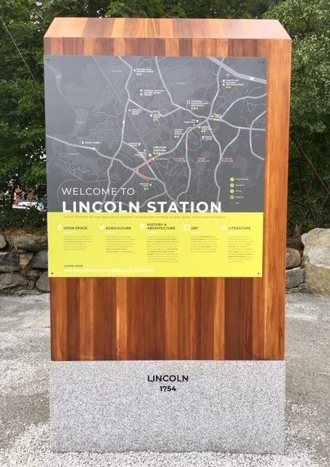
Introduction

The new Housing Choice (3A) and Village Center Overlay Districts provide an opportunity to create a vibrant and pedestrian-friendly village center by encouraging a mix of residential and non-residential uses in close proximity to the Lincoln Commuter Rail Station. The new zoning promotes both multi-family housing and mixed-use development near our public transportation, shopping, and services, and responds to critical local and regional needs for housing. This vision is based on years of robust planning processes, including the 1998 South Lincoln Planning Study, the 2009 Comprehensive Plan, the 2014 Lincoln Station Planning Study, and subsequent work by the South Lincoln Planning Implementation Committee and South Lincoln Planning Advisory Committee. With the passage of the Housing Choice Act and work by the Housing Choice Act Working Group and the Planning Board, the Town of Lincoln created zoning that responds to years of prior and recent work. The Town now looks to the future to create a village center neighborhood that promotes decades of planning and embodies the values of the Town Vision Statement.
In this document, The Village Center Overlay District will be referred to as the VC District. The area encompassing both the 3A and Village Center Overlay Districts will be referred to as the village center.
These design guidelines are intended to supplement and complement the new zoning by providing guidance for project planning and design. Their purpose is to provide property owners and developers with direction regarding Lincoln’s goals for developing this area, and to offer current and future Planning Boards a framework for reviewing proposed projects.
These guidelines shall apply to all new development and redevelopment in the 3A and VC Overlay Districts subject to Planning Board site plan review or Planning Board special permit review and are intended to ensure that development will be high quality and will help form a cohesive neighborhood through construction of compatible building forms, inviting streetscapes, and other important community features. These guidelines are intended to promote critical design elements that will ensure the area grows and develops according to the Town’s vision.
Throughout these guidelines, various images are used to illustrate key points. Note that these photos are for illustrative purposes only and are not intended to represent actual recommendations or proposals.

Principles

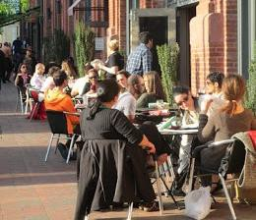
As described above, the purpose of these guidelines is to provide guidance on how to promote the Town’s goals and objectives for the 3A and VC Overlay Districts as expressed through physical design. Together with the regulations specified in Lincoln’s General and Zoning Bylaws, these guidelines will:

- Promote the village center as a vibrant commercial district and local destination with a mix of uses, services, and amenities, and as a gathering place and center of local public life with active streets and public spaces.
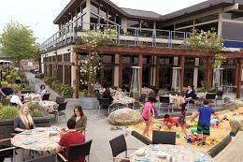
- Encourage increased opportunities to live in the village center through a variety of housing options for households of varied incomes, ages, and sizes, to support the businesses of the village center and add to the vitality and long-term economic stability of the area.
- Enhance connectivity so that new and existing uses are connected to Lincoln’s commuter rail station and robust roadside path and trail network through safe, pedestrian-friendly streets and trails. Interconnectivity across the districts will reinforce the sense of a village neighborhood through texture, form, and scale.
- Ensure new buildings are in keeping with the scale and character appropriate for a village center and support the high quality of design and connection to the outdoors that Lincoln values.

Site Design


Site design, or how the different pieces of a project are arranged on a particular site, is the foundation of good design. A thoughtful site layout can create welcoming spaces, encourage walking and pedestrian activity, support healthy and vibrant retail districts, and ensure that new development contributes to the creation of a neighborhood and feels like an integral part of existing neighborhoods. The Planning Board will consider how current proposals will enhance the connectivity and vibrancy of the existing environment and how the proposal will contribute to ensuring a vibrant area into the future.

Building Location
Buildings should be deliberately located on the site in such a way that they define the edges of adjacent open spaces, yards, or sidewalks. In some cases, this may mean that the building is relatively close to the sidewalk in order to allow for the building to become a part of the pedestrian experience. In other cases, this may mean a modest setback or front yard to allow for visual relief, public amenity, or privacy for building residents.
As part of the site design, consideration should be given to how the buildings relate to the landscape. Buildings should be oriented and scaled to encourage the use of outdoor spaces. In all cases, the building(s) should be situated so that the adjacent open spaces are intentional and defined, rather than leftover space. Further details on site landscape design are provided in the Public Amenity section below.

A strong connection between the building and sidewalk is particularly important for mixed-use buildings where ground floor retail will benefit from foot traffic and a pedestrian’s ability to see the activity happening within the building. Additional details on sidewalk design are also included in the Public Amenity section below.

Where more than one building is included on a lot, the buildings should be grouped to have a meaningful relationship to one another. Well-defined, tight building groupings can provide small-scale, well-defined open space while also preserving natural landscape outside the building groupings. This is preferred to a scattered or sprawling site plan with undefined open space between buildings.

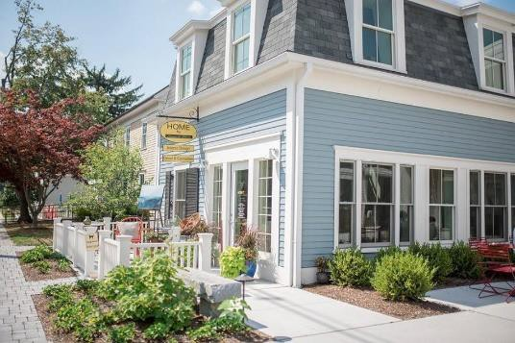
These buildings are close enough to the street to have a strong relationship to it; the space between the building and the street is well-defined and serves as a public amenity.

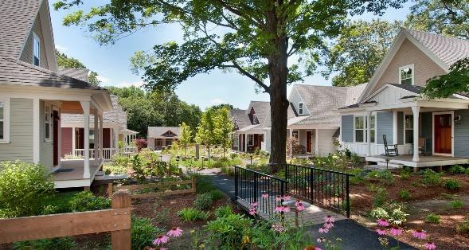

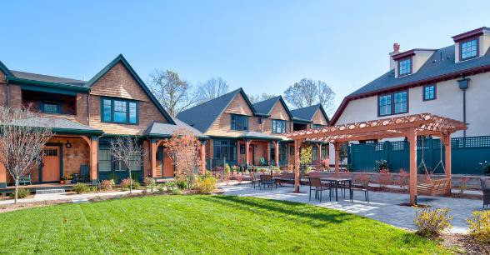
If there is more than one building in a development, compact groupings with well-defined open space are preferred.

Building Orientation
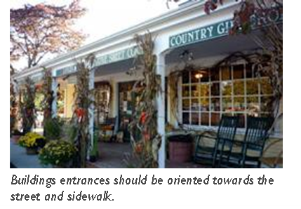
A building’s main façade should be oriented towards the street, especially in mixed-use buildings. Its primary entrance should be clearly visible from, and accessible from, the street and sidewalk. Because these guidelines require that parking be located behind the building, a second entrance that is directly connected to the parking lot may be desirable; if this is the case, the two entrances should work together within the internal building circulation and should complement each other, not compete with each other.
Alternative orientations will be considered if there are multiple buildings on a lot and only one access from the street.
Any reference to streets in this document includes the frontage of the right of way from which the site is accessed. It also includes privately-owned rights-of-way that are used as the primary approach route to a new development.
These guidelines envision the village center as a well-connected neighborhood with pedestrian-friendly access and a strong relationship between buildings and the roads used to approach them, regardless of whether those roads are publicly-owned streets or privately-owned rights-of-way.

Open Space
Open space of all varieties – from trails to gathering spaces to woodlands - is a valued asset in Lincoln. Where a front yard or other private open space is adjacent to the sidewalk or other public open space, it should relate to the public open space and serve as a visual amenity for all. It is critical that front yards not be treated as leftover space but should be as carefully designed as the building itself. For mixed-use projects, sidewalks, and outdoor spaces adjacent to buildings should be designed to accommodate outdoor seating and gathering areas that complement the commercial space within the buildings.
Site design shall incorporate current best practices for storm water management and use green infrastructure techniques, such as bioswales and rain gardens. For an introduction to the principles that govern ecologically sustainable development, please see the Lincoln Conservation Department’s Ecological Design, Construction, and Maintenance Handbook.
Front setbacks for multi-family projects will most likely function as a private yard but should nonetheless constitute a visual amenity for those passing by. In the VC District, utilization of the front setback area for publicly accessible use is strongly encouraged. (see Public Amenity section).

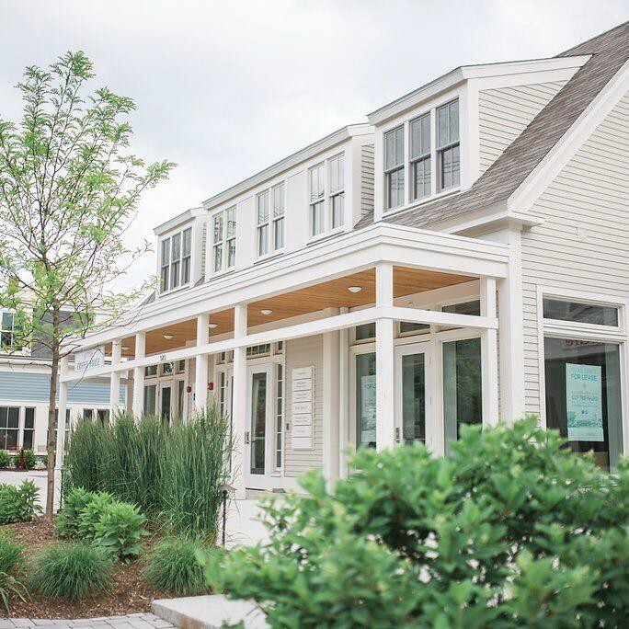

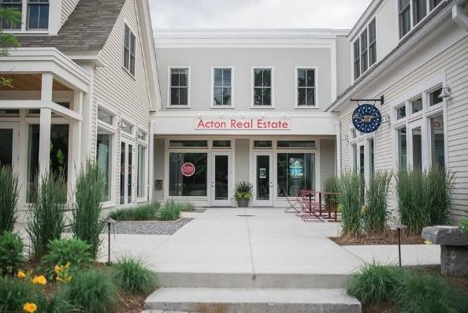
Examples of open space integrated into development. The plaza in the bottom image is clearly publicly accessible. The landscaped area in the top image is private, but still provides a visual amenity for pedestrians.

Pedestrian and Bicycle Connectivity
The Town of Lincoln is popular for recreational cyclists, family cyclists, walkers, and runners. Lincoln’s extensive roadside path and trail network is one of the attributes that makes it special. The ability to walk and bike to and within the village center should be central to the design of projects. Any new project should enhance connectivity, both internally and externally. Within the site itself, ensure that all building entries connect to a sidewalk or path. At the edges of the site, connect to and continue any adjacent pathways and if possible, create connections to adjacent trails. Pay attention to informal use paths through the site; these should be respected and incorporated into the site design if appropriate. Sidewalks should be provided along all streets, even where sidewalks do not currently exist; crosswalks should be provided where paths intersect with roads or parking lots. Please refer to the Public Paths and Sidewalks subsection within the Public Amenity section below for further details on fostering safe pedestrian and bicycle connectivity within and around a development.
.

Vehicle Access and Parking
The village center is envisioned as a pedestrian friendly neighborhood where residents or visitors arriving by any mode of transportation – rail, walk, car, or bike - can move safely between points of interest. Those who choose to drive to the village center, should be encouraged to park once and then walk between businesses and public spaces.
To encourage an active pedestrian environment, surface vehicle parking shall be located behind or to the side of buildings and shall be minimally visible from the street; the most visually prominent part of a new development should be the buildings, sidewalks, or open space. If applicable, consider wrapping first-floor podium parking with other uses. Avoid placing parking between a building and the street or in such a way that might make pedestrian flow secondary. For commercial spaces, a modest amount of parking adjacent to the front of commercial spaces may be desired and can create a sense of activity. Such parking should promote the pedestrian experience and should be buffered with vegetation, street trees, low walls, or other site features. The visual impact of surface lots can also be reduced by integrating vegetated and/or treed islands into the parking area.

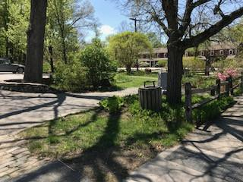

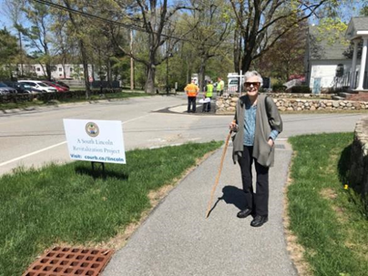
Lincoln’s network of pathways and trails is one of its defining features. Connecting to and expanding pedestrian connectivity is critical.

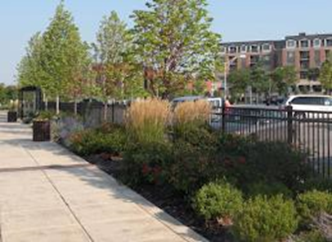
When parking is located adjacent to the sidewalk, it should be screened with landscape or site features.

The careful design of parking is particularly critical in the VC District and the Lincoln Road/Lewis Street subdistrict, where a relationship between the sidewalk and storefronts is an important part of encouraging foot traffic to local businesses. Project proponents are encouraged to work closely with the Planning Board to develop ways in which adequate parking can be provided to bolster the success of the commercial component of the development while maintaining an environment that supports the overall pedestrian experience.

To allow for a more compact development pattern that will support increased activity in the village center, the amount of space devoted to parking should be minimized. This could be accomplished through shared parking between compatible uses, or by wrapping ground-level parking with retail or residential uses.

The VC District and the Lincoln Road/Lewis Street subdistrict are intended for a mix of uses and are particularly suited for shared parking. Parking should be designed to
encourage shared use across tenants and across
properties, particularly for mixed uses that might see different peak periods of parking demand. Sharing can be facilitated by providing driveways that connect adjacent parking areas, sidewalks that connect adjacent parking areas, and combining parking access to reduce curb cuts.

Curb cuts disrupt pedestrian and bicyclist path of travel; both their number and width should be minimized. To reduce the number of curb cuts, shared driveways or shared vehicular access points are encouraged. Where a building fronts more than one street, the curb cut should be located on the secondary street if feasible, away from the street corner, to minimize conflicts between vehicles and pedestrians. Every curb cut should provide a continuous and uninterrupted pedestrian walkway, and all curb cuts should be designed so that driveways slope up from the street to the level of the sidewalk.

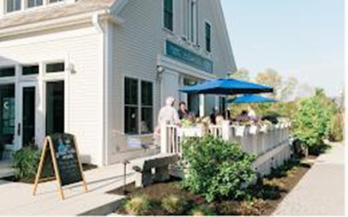
Placing parking underground or wrapping it with active uses minimizes its impact on the pedestrian environment. In the example above, parking is located underneath and behind the café which allows the café to have a sidewalk presence.

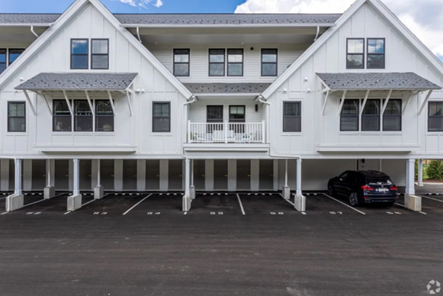
Here is an example of podium parking with two floors above.

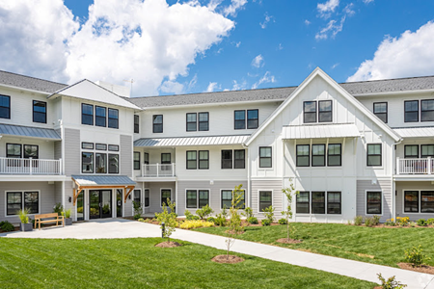
Here is the front of the same buildings.

Service Areas

Back of house functions, such as trash areas, utilities, loading docks, or mechanical equipment, should be minimally visible from the street and abutting residential properties. It is preferable for these uses to be located to the rear of the building or on the building roof, so that the building itself screens them from public areas. Building design and orientation that act as barriers to back of house functions is encouraged.
Service and mechanical functions should be screened with landscape elements or high-quality materials.
When located on the roof, mechanical equipment shall be screened from view using architectural forms integrated into the roof design. When located at grade, these features shall be screened using vegetation, fencing, landscape feature, or other architectural element so as to not be minimally visible from streets, adjacent properties, and public spaces. When fencing is used for screening, it should be used judiciously; a continuous tall fence reads the same as a blank wall. In general, landscape is preferred over fencing as a buffer. If fencing is provided, natural or decorative materials are preferred. Chain link fencing is not permitted. If the use that is being screened generates noise, the screening element shall incorporate soundproofing.
In residential buildings, an often-forgotten service function is storage for building residents. Consider providing residential storage areas in the form of basement storage, sheds, or garages to minimize clutter outside the building. Bicycle racks and covered bicycle storage must be part of any residential building design.

Buildings: Scale and Massing
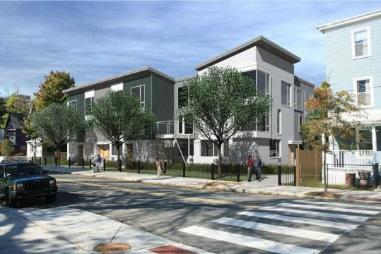

While the 3A and VC Overlay zoning is intended to encourage additional housing, mixed use, and retail options, this goal should be accomplished within the context of Lincoln’s built character. Architectural elements such as varied heights, bays, or step-backs can be used to reinforce the scale, massing, and proportions of the village center’s established forms of development. A hierarchy of details and forms can draw the eye to important building elements, bringing the building to a human scale and reducing the appearance of height and bulk.

Building Scale
Scale in architecture is a measure of the relative size of a building or building component in relation to its surroundings. The perceived scale of any building is a function of the overall size of the proposed building relative to surrounding buildings, and the visual relationship of the building’s façade elements to each other and to those in the surrounding buildings.
Buildings need not be of a uniform height to be properly scaled. The height should, however, complement nearby buildings through the use of step-backs or half-stories to break up the building’s mass and reinforce the scale and proportions of nearby structures. This is particularly important if the building is located near smaller scaled structures.
Consistent with the building heights allowed in the Zoning Bylaw, buildings fronting Lincoln Road are intended to reflect the Town’s existing character.

Although this building is wider than the surrounding buildings, the bays and front setback ensure that it is not out-of-scale with its surroundings.

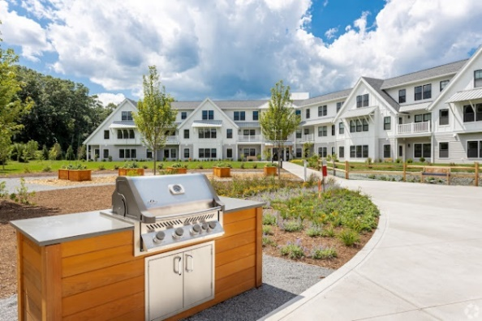

An example of the 3-story height that is envisioned along Lincoln Road (above), The top story within the roof line mitigates the perceived scale of the building.

Building Form
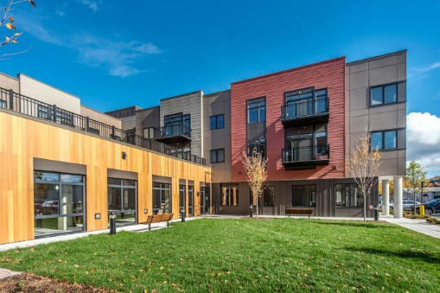
Form is the three-dimensional shape that a building takes. Variations in building form can be used to reduce the appearance of larger buildings. Large building masses and volumes should incorporate recesses and projecting forms at intervals appropriate to the surrounding context. These forms could be large-scale, such as a bay that runs the entire height of a building, or smaller scale, such as projecting windows or dormers.
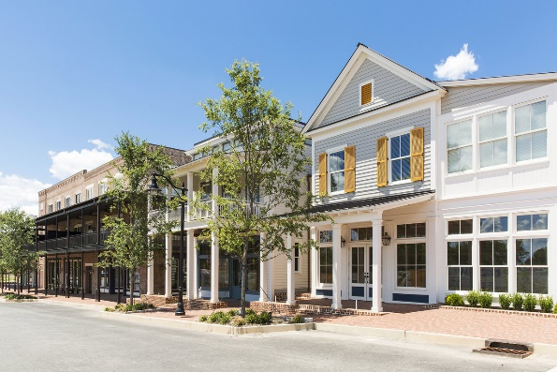
Buildings should incorporate design strategies aimed at bringing the scale of a building down.

Roof Form
Because of Lincoln’s rich and diverse architectural history, different roof forms may be appropriate: pitched, gabled, mansard, or flat. Whichever roof form is selected must be consistent with the overall architectural style of the building, serve to visually cap the building, and be proportionally scaled to the building overall.

Ground Story
In regard to the VC Overlay and Lincoln Road/Lewis Street subdistrict, when incorporating commercial uses, a taller ground story shall be incorporated into the design. Active ground floor uses are strongly encouraged and should be clearly visible to contribute to district vibrancy. Ground floor stories in commercial or mixed-use buildings must be a minimum of 12 feet in height.
While a tall ground story is less necessary for residential ground floor use, it is often still desirable to use increased ground floor height to visually ground the building by emphasizing its base. Additionally, residential buildings have active uses that may be appropriate in visually prominent areas; consider placing lobbies, mail areas, community rooms, lounge areas, or other common spaces on the ground floor.

Examples of varying building and roof forms.


A tall ground story is encouraged for commercial use.

Buildings: Articulation

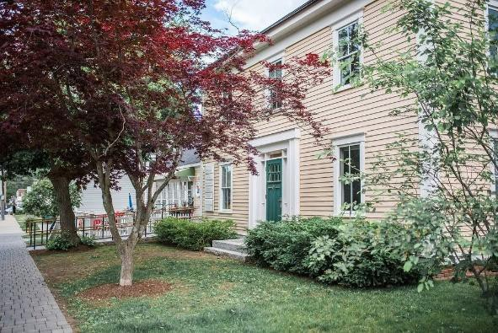
Building articulation is the way in which various building elements and details come together to form a cohesive whole. In a well-articulated building, the various façade elements are used to reinforce human-scale proportions and reduce the visual impact of larger building massing.

Architectural Style
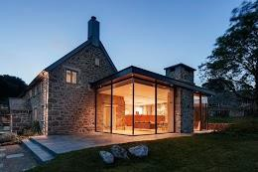
Lincoln has a strong design heritage that ranges from Colonial to Modern. New development need not adhere to any specific architectural style, but should always be complementary to, and specific to, the local Lincoln context. Generic designs should be avoided. The use of innovative technologies and materials to enhance design, rather than attempting to mimic past design styles, is encouraged.

Façades
As the face of the building, the façade should enhance the visual character of the building and the neighborhood. The façade elements of buildings in the village center area should provide visual appeal, avoid monotony, reduce the appearance of bulk, and provide a visual relationship to adjacent buildings. Where more than one façade is visible from the street or a public space, both facades should be treated as primary facades through detailing and materials. Blank wall surfaces greater than 20 linear feet are not permitted when visible from the street or public pathways.
Building expanses more than 50’ in width shall be broken into bays or otherwise articulated to reduce the appearance of mass and to reduce the perceived scale of the building.
Façades should not be considered two-dimensional elements but should be enhanced by variations in depth. This may be accomplished through the use of balconies, changing materials, or architectural detailing to provide visual appeal and to break down building scale.

Windows
The arrangement, proportion, and style of windows should be consistent with the architectural language of the overall building. Windows are the most common way to relieve blank, uninteresting surfaces and can add depth to an otherwise two-dimensional façade. Their spacing creates a visual rhythm that reinforces the building’s forms.
Windows should be used to expand the use of natural light and to encourage the connection between the indoor and outdoor environments. For commercial spaces, windows should allow pedestrians to easily see the activity inside the building.
Glazing shall be transparent, not reflective, mirrored, or tinted.
For ground floor retail and other street activating uses the façade fronting the public and/or privately owned street shall be at least sixty (60) percent transparent. All other façades facing a street or public space shall be at least thirty (30) percent transparent. Exemptions may be allowed with Planning Board approval.
All other nonresidential uses (excluding retail) facing the primary street frontage shall be at least forty (40) percent transparent. All other façades facing a street or public space shall be at least twenty-five (25) percent transparent.
Transparency shall be calculated as the percentage of clear, non-reflective glass within the area between three (3) feet and eight (8) feet above the first-floor finished elevation. For retail uses, windows on the ground floor shall be at least five (5) feet high.
Transparent doors and window mullions shall count as part of the transparent area.

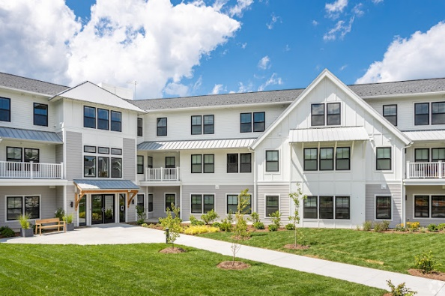

Bays and projecting forms are used to provide visual appeal and break down building scale

Entrance
The building entry should be clearly identifiable and should be visible and accessible from the sidewalk and from parking areas. The entry should be both a visual focus point for the building and should be integrated into the overall façade and configuration of the building form. In addition to a prominent location and clear paths, the entrance can be emphasized by adding architectural features, such as overhangs or canopies (discussed further below), or subtracting mass, as in the case of recessed entries.
Recessed entries can add depth to a building façade and create a transition space between indoor and outdoor. At a minimum, entrances located directly on sidewalks or paths should be recessed to a depth equal to the width of the door to prevent doors from swinging into the pedestrian path of travel.
For mixed use buildings, entrances to upper floor uses should be separate from ground level retail entrances.
For residential buildings, there should be a hierarchy of entrances; the main entrance to an apartment building should be more prominent than the entrance to a townhouse or individual dwelling unit. However, individual unit entries can still be emphasized with stoops, small porches, or other more residential elements.



Window arrangement and style should be consistent with the architectural language of the overall building. Upper story residential windows should be differentiated from ground level commercial windows.

Ground-level transparency enlivens the sidewalk and provides a glimpse of activity within.

Recessed entries add depth to the façade and create a transition between indoor and outdoor.

Overhead Coverings
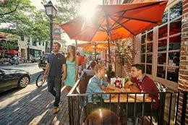
Overhead coverings can highlight a building entry, provide articulation and detail to break up a façade, provide protection from the elements, and create a transition zone between public and private space. They can include awnings, canopies, covered porches and recessed or covered walkways.
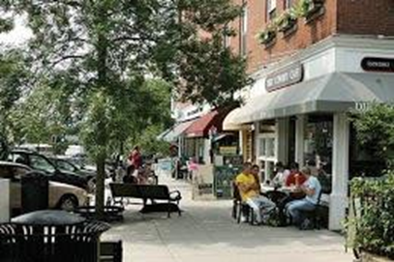
Awnings should fit the shape and scale of the window or door, and their style, shape, and scale should be compatible with the overall building design. The color and pattern of the awning should be carefully selected; a facade with minimal architectural detailing can be enhanced with bright colors and patterns, while a more decorated facade may be complemented with a plain, subtle shade

Materials
Materials add color, texture, and detail to a building’s exterior. Materials should provide layers of visual interest, allowing for different characteristics of the material to become apparent whether it is viewed from across the street or from the front entrance. Exterior materials should be high quality and durable. In general, natural materials, such as brick, wood, or stone, are encouraged; however, it is most important that materials selected should be in keeping with the character and style of the building. Innovative technologies and materials that enhance design may also be appropriate. Artificial, low-quality materials or those that are likely to deteriorate are discouraged.

Details
Architectural details on buildings create interesting facades and reinforce the human-scaled aspects of the building design. Such details may include, but are not limited to, items such as the trim around entrances, corners, eaves, doors, and windows; the ways in which different materials interact and overlap; or type and style of windows and doors. Finer building details should be consistent with the overall architectural design.
Within mixed-use developments, in addition to active uses, the physical architecture of the ground floor should be distinct and should signal activity. The façade detailing should clearly define the commercial ground floor and differentiate its articulation from residential uses on the upper stories. This articulation of the ground level of a building shall be used to visually anchor the base of the building on the site and to define a human-scaled base at the primary street frontage.



Architectural details add interest to traditional building forms (above); articulation of the ground floor visually anchors the building (middle and lower).

Signage and Outdoor Displays


Signage is needed for businesses to let people know what services they provide. Signage can also be a way to add interest to a building’s appearance. Signage in the village center should fit with and reinforce the architectural character of the building. Signs for buildings with multiple tenants, including directories, shall be coordinated on a free-standing sign or across a building facade to offer clear, orderly, and legible information about the building and tenants. Signage may not be placed on the upper facade above the second story of multistory buildings unless the business itself is located on an upper floor. If a business occupies a space with more than one façade, signage on both frontages may be considered by the Planning Board. Hanging signs, wall-mounted signage, signage on canopies, and carefully painted window signs are encouraged. Backlit signs and internally lit signs, including neon signs, are not permitted by Lincoln’s Zoning Bylaw.
Display areas can activate a street and provide visual interest if they are thoughtful and not haphazard. Displays should be organized and should not add clutter to the sidewalk.

Formula Businesses
Formula businesses have a standard aesthetic and branding across multiple locations. In the village center, any standardized branding shall be subordinate to fulfilling the recommendations in these guidelines. This means that the building design, from site plan to signage, should be of high quality and should be adapted to complement the local character of the district. Standardized, stock designs are not permitted.


Examples of signage (above), and well-organized storefront display (below).

Sustainability

All development, whether commercial or residential, new construction or renovation, shall comply with the Town’s Specialized Stretch Code as well as the requirements of the Ten Town Demonstration Project as incorporated in the Town’s General Bylaw. All projects should also incorporate sustainable practices to the greatest extent possible. Projects are strongly encouraged to go beyond the basics and push the envelope in advancing environmentally responsible design and construction.
Although sustainability is a standalone chapter here, it is intended that sustainability features be considered and integrated into all aspects of the development. Many of the design strategies recommended elsewhere in this document, in the General, and

Although sustainability is a standalone chapter here, it is intended that sustainability features be considered and integrated into all aspects of the development. Many of the design strategies recommended elsewhere in this document, as well as in Lincoln’s General, and Zoning Bylaws promote sustainability. Such strategies include promoting the following: reduced and shared parking, alternative modes of transportation, , reduced impervious surfaces and consequent stormwater runoff, multifamily use with shared walls that naturally minimize energy loss, and compact development footprints that reduce impact to natural open space.
While these guidelines highlight high-level sustainability concepts that should be considered in any development in the village center, the strategies discussed here are only a start. The field of sustainable development is complex and continually evolving. To ensure projects are addressing the full range of sustainability considerations - energy efficiency, renewable energy, water efficiency and management, sustainable materials, indoor air quality, and new innovations - applicants are encouraged to consult with green design professionals from the outset of project planning, and projects are strongly encouraged to be certifiable by a recognized sustainable building standard such as the U.S. Green Building Council LEED Rating System.

Roof Solar
The site and building layout shall be designed to benefit from an effective solar orientation for passive heating and cooling and use of renewable energy sources on site. Buildings should incorporate solar panels where possible. Where flat roofs are used, consolidate roof penetrations so as to maintain adequate space for the eventual installation of solar panels. For buildings with sloped roofs or step backs, orient the primary roof surface towards the south where possible, to maximize the potential for solar panels. Buildings’ impact on the solar access of adjacent properties should be minimized. Finally, consider solar orientation when designing the layout, size, and type of windows to incorporate passive solar gain and natural lighting. Sun shading, daylighting, and other passive techniques should be seamlessly integrated into the building design.
Photovoltaic solar panels are only one of many sustainable opportunities afforded by a buildings’ roof surface. A solar thermal system, rather than generating electricity, can pre-heat a building’s water to reduce the energy needed for water heating. A green or vegetated roof reduces heat loads on a building, offers a high level of insulation, and captures stormwater runoff. White or “cool” roofs reflect more light than they absorb, lowering the temperature of the air around the roof and helping to reduce building cooling loads and heat island impacts. Finally, a “blue roof” is designed explicitly to manage stormwater. No matter what system is used, roof surfaces offer a range of sustainability opportunities.
Getting to Net Zero
Development is strongly encouraged to minimize its energy consumption to the greatest extent possible. It is expected that development will include standard energy-reducing features such as enhanced insulation and envelope sealing, efficient appliances and systems, LED lighting, and electric vehicle charging stations. Projects are also encouraged to consider more significant energy reduction measures. This could be accomplished through an advanced energy efficiency standard such as Passive House, Living Building, or LEED Zero (with or without formal certification). It could also be achieved through the proactive use or piloting of innovative, holistic, and site-specific mechanisms to reduce energy usage.

Public Amenity


Any vibrant neighborhood includes places for people to gather, whether formally or informally. Lincoln has a strong tradition of fostering public open spaces, and new development should continue this practice. In all cases, providing opportunities for public amenity should be an integral part of site design and should not be an afterthought.

Within the VC District and commercial or mixed-use projects in the Lincoln Road/Lewis Street subdistict, all new developments should include accessible public space, located on the site to promote pedestrian and shopper accessibility. These areas may include pedestrian-friendly amenities, such as wide sidewalks/pathways, outdoor seating, patios, or courtyards, as well as landscaped/garden areas associated with these pedestrian amenities. It may include landscaped pathways connecting adjacent developments but may not include painted pathways/crosswalks through parking lots.
The design of public space should clearly communicate that the space is open to the public. Where appropriate, front setbacks should be used to accommodate plantings, public seating areas, outdoor restaurant seating, or similar uses. Landscape is a critical piece of thoughtful public space design; refer to the following section on Landscape for more information.

Public Paths and Sidewalks
The design of sidewalks and paths should promote and encourage walking and biking. As highlighted in the previous section, connectivity should be a defining feature of the village center area and should be included along all streets. Pedestrian paths and sidewalks within the site shall connect with those of adjacent developments and with adjacent Town trails. Any public path, trail, or sidewalk which currently extends through a project site shall be maintained. Any public path that currently terminates within the site or at the site boundary shall be extended so that it continues through the site. These paths shall be publicly accessible.

Sidewalks and paths, and the elements located within them, should foster comfort, safety, and accessibility for all pedestrians. All sidewalks and paths should be a minimum of 5’ wide for

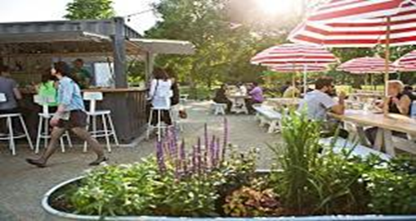
Examples of accessible public space that serve to enliven the village center.

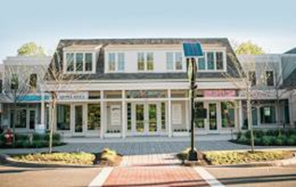
Example of a well-marked mid-block crossing

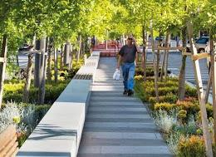
strictly pedestrian use, 6’-10’ for shared use paths, and should be free of obstructions. At street corners or where mid-block crossing is desirable, integrated curb ramps and clearly marked crosswalks should be included. Because of their superior visibility, crosswalks shall be in the continental or ladder style and comply with specifications developed by the Town’s Transportation Coalition.

Sidewalks shall be constructed of high quality, durable materials, such as concrete, asphalt, and stone pavers. Sidewalks must be well constructed and maintained for smooth and accessible surfaces; this is particularly important if the primary material is brick or unit pavers. If brick or unit pavers are used, the sidewalk must be detailed and maintained to ensure accessibility. If asphalt is used, appropriate edge detailing should be incorporated. If the Planning Board adopts a specific palette of sidewalk materials to create a cohesive district aesthetic, the project’s sidewalks must be consistent with that palette.

All new sidewalks, paths, and curb ramps shall be designed and constructed to be accessible to persons with disabilities in accordance with applicable laws including the Americans with Disabilities Act and the Rules and Regulations of the Massachusetts Architectural Access Board.

Consistent with the desire for public space, small setbacks to provide space for landscape or seating are encouraged. Where this is provided, the sidewalk or path must provide adequate space for all users and maintain at least an additional 5’ clearance for pedestrian circulation around any street furniture, trees/plantings, bicycle parking, or restaurant seating.

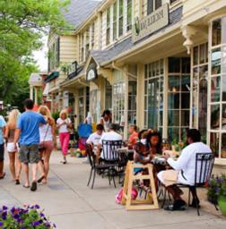
Where plantings and café seating are provided, the sidewalk is wider to provide adequate clearance for pedestrian circulation.

Landscape
A thoughtfully designed landscape appropriate to the context of the building and the surrounding streetscape is a critical piece of any project’s design. Landscape features define edges, frame streets and public spaces, shield negative views, and reinforce the overall village form that is envisioned for Lincoln’s village center. The streets, plazas, courtyards, and gardens of the village center are the open space components of village form, and their appeal will result in part from the incorporation of appropriate types and locations of plantings.

In general, plantings related to streets and plazas should favor shade and flowering trees with continuity of species within a given area. Trees should be selected for their tolerance of the built-out microclimate; plants located near streets, driveways, or parking lots should be salt-tolerant. Plantings should not obscure site entrances, exit drives, access ways, or road intersections or impair visibility of commercial storefronts. Tree species should be selected to maintain relatively clear views of the ground floor and adequate height clearances for sidewalk circulation. Plants should be located in open plant beds as opposed to being planted in pavements with tree grates.

Plants and trees in parking lots should be located in islands of sufficient size to provide air and water to reach the root systems. Tree species that have smaller leaves that minimize leaf litter should be considered. Irrigation should be considered to help plant survival in this difficult growing environment.

Seasonal plantings should be encouraged, particularly in the form of planters associated with retail shops, cafes, and other public spaces. Tenants should assume responsibility for their care and maintenance. Planters should be of durable materials and of a design quality that compliments the particular setting.

Plant species should be drought-tolerant and non-invasive. Native plants are preferred, but non-native plants are permitted provided that they are not invasive. When selecting plants, consider the Lincoln Conservation Commission’s list of recommended native plants (note that this is one resource of many, and should not be considered exclusive). Artificial plants are not permitted.

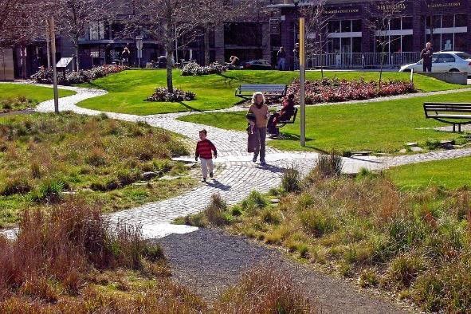
A well-designed landscape defines edges, frames views, and creates welcoming public space.
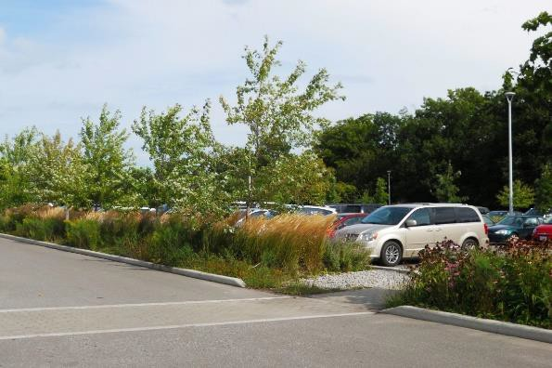
Plants in parking lots should be in islands of sufficient size to provide air and water to reach the root systems.

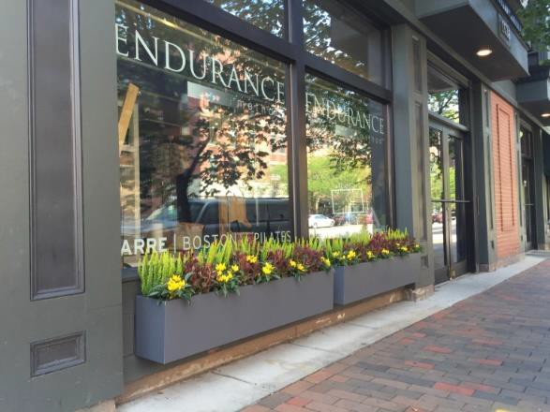
Seasonal plantings associated with retail shops are encouraged.

Street Furniture
Street furniture describes a variety of pedestrian amenities, including formal seating such as benches or café tables, trash and recycling receptacles, informal seating such as functional walls, bike racks, light fixtures, or planters. All street furniture should be integrated with street and sidewalk circulation to ensure adequate clearance, access, and convenience of the location of these amenities.
Public art is encouraged. All art installations shall maintain clearances in public spaces, and be constructed of materials that are durable, easily maintained and that do not present safety hazards.

Bicycle Parking
Bicycle parking is required for new development: One space for every 15 parking spaces, with a minimum of two bike spaces or as otherwise determined by the Planning Board. Bike parking should be located to address safety, visibility, access, and aesthetics. Bicycle racks should be installed in a manner that does not obstruct pedestrian or vehicle traffic. Either traditional or artistic bike racks are allowed if they meet the Guidelines criteria.
Bicycle racks should support an upright bicycle by its frame horizontally in two or more places and be installed on a permanent foundation (e.g., concrete pad) to ensure stability. Racks should be designed to prevent the bicycle from tipping over and support a variety of bicycle sizes and frame shapes. Racks should include space to secure the frame and one or both wheels to the rack with a cable, chain, or u-lock. The diameter of locking pole should be no more than 1.5” and the rack should connect to the ground in such a way as to not collect leaves and debris.
For development with retail use, bicycle parking shall be located in a prominent location visible from the main building entrance. In addition, any property owner may elect to establish a shared bicycle parking facility for multiple tenants.


Street furniture that provides places to rest and observe is important for pedestrian comfort.


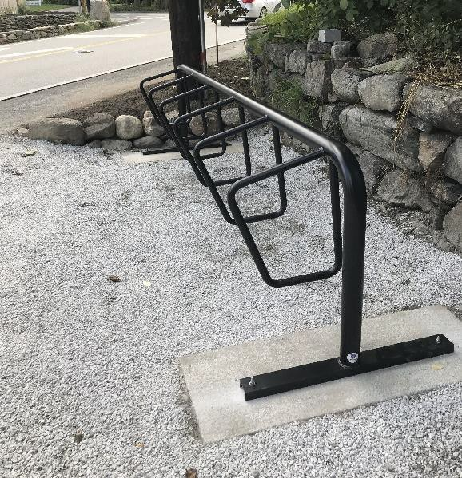

Examples of artistic and traditional (flat black powder- coated) bike racks.

Wayfinding
Any public directional signage must be consistent with the current wayfinding signage in terms of branding and appearance.

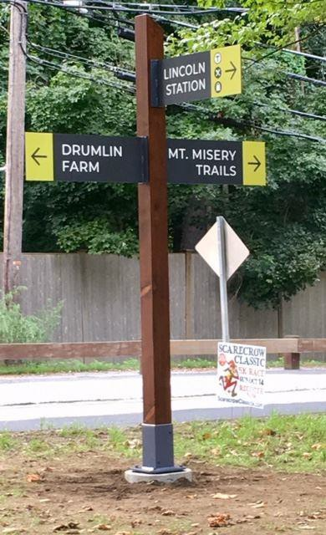
South Lincoln’s wayfinding signage.

